

KS4 Homework Tasks
2026-2027

To support students with early and ongoing revision for assessments, mock exams and GCSE exams, homework tasks for KS4 will be set from one of the activities below.
You will use a knowledge organiser to complete each task. Your teacher will provide you with knowledge organisers or they can be found on the home learning page of the Newmarket Academy website.

- Look, Say, Cover, Write, Check – Great for learning definitions and key facts
- Flash cards – Ideal for self quizzing.
- Revision clocks – Chunking content into manageable parts
- Mind mapping – Visual, creative and great for linking ideas
- Sketch noting - For those that think in pictures.
- Exam questions – Practice answering questions and self-assessing using examiner markschemes

Your teacher will give you instructions on which knowledge organiser to use and which task to complete.
All homework will be recorded on Arbor and all tasks will be handed in to your class teacher on the date given

- Look, Say, Cover, Write, Check

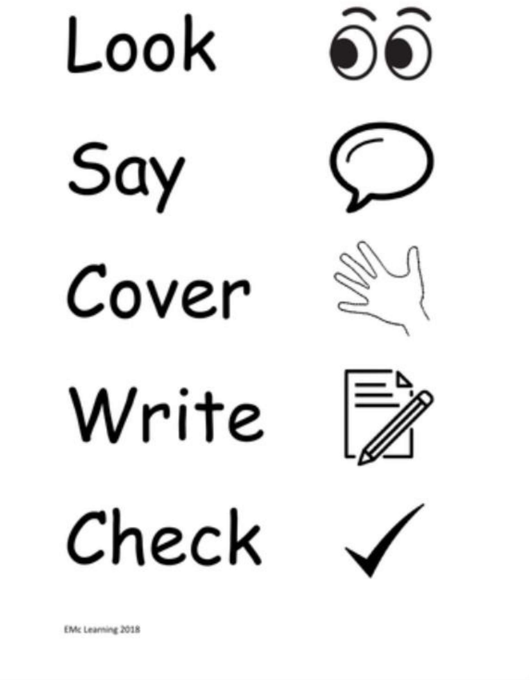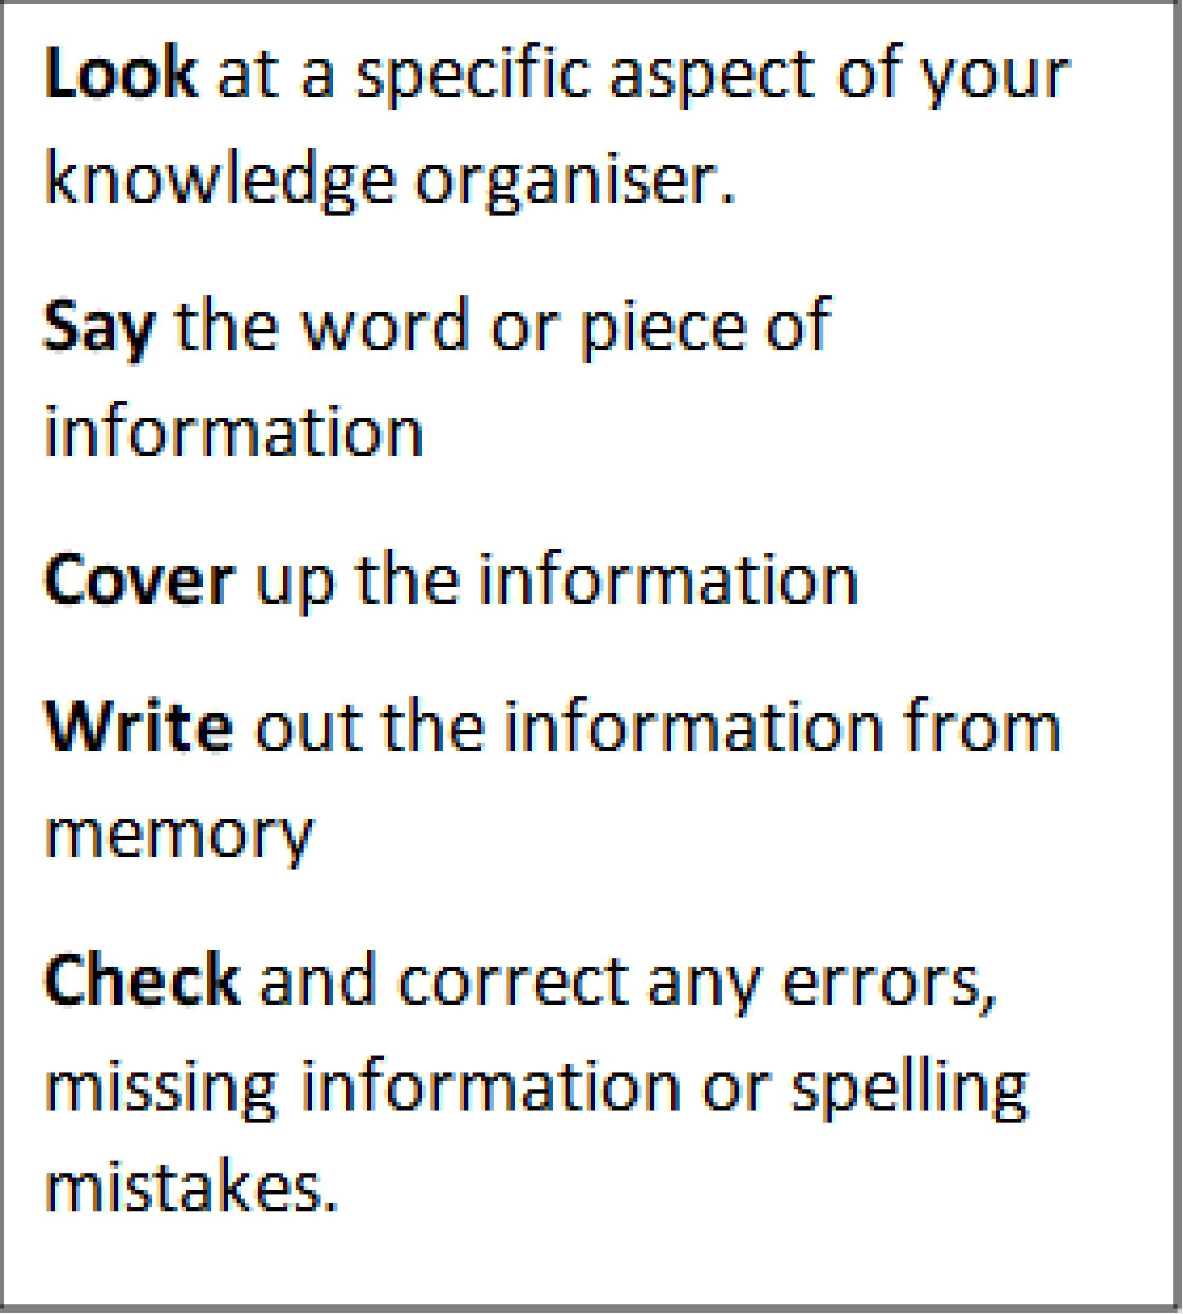

- Flash Cards

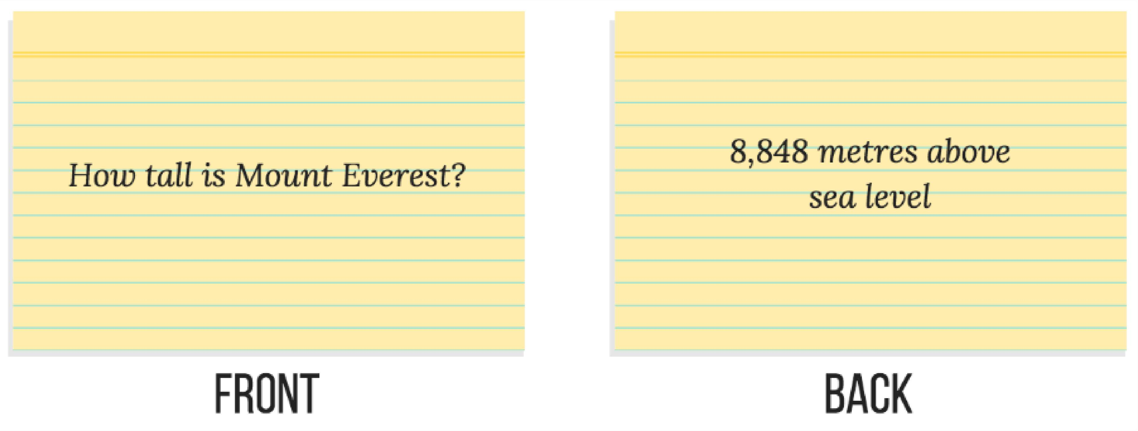

Instructions to complete a set of flash cards
- Write the question on one side and on the other side write the answer
- Create for keywords and definitions
- Create for summarising arguments – agree and disagree
- Test yourself to make sure you know all of the key information for the topic
- You could also use the flashcards to test yourself on the definitions of the key vocabulary. Remember you need to revisit information 10 times for it to be embedded in your long-term memory

- Revision Clocks

Creating a revision clock
1.Draw a clock: On a blank piece of paper, draw a large circle to represent a clock
2. Divide into segments: Divide the circle into 12 equal segments, like the face of a clock
3. Assign sub topics: Label each of the 12 segments with a sub topic from the larger topic you are revising
4. Use a timer: For each segment, use a short, timed interval, such as 5 minutes
5. Fill with notes: Work clockwise, filling each segment with brief, focused notes or diagrams. You can write information you already know and add new details in a different colour to highlight areas for further study.
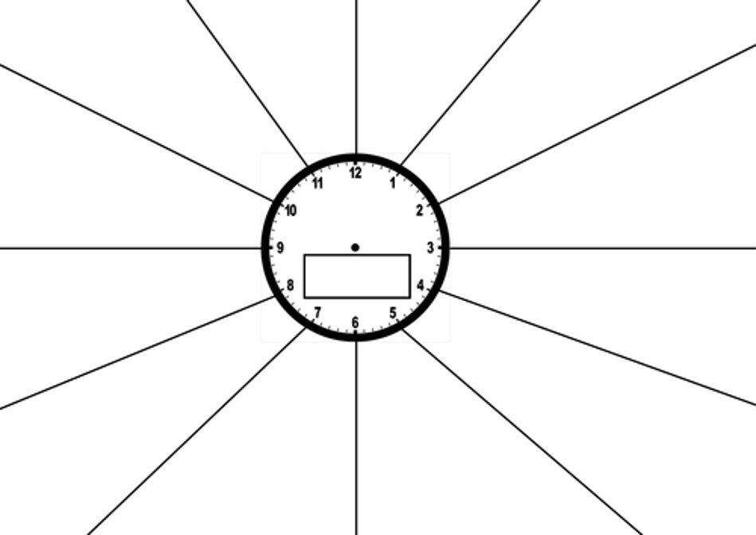
Completing and testing with your clock

- Self test: Once you’ve completed the clock, cover up the segments
- Recall information: Try to recall the information in each segment from memory
- Check and correct: Check your recalled information against your knowledge organiser, correct any mistakes and add any missing information
- Identify knowledge gaps: Use colour-coding or highlighting to mark areas you are confident about (green), have some understanding of (yellow/orange), or need to revise further (red/pink)

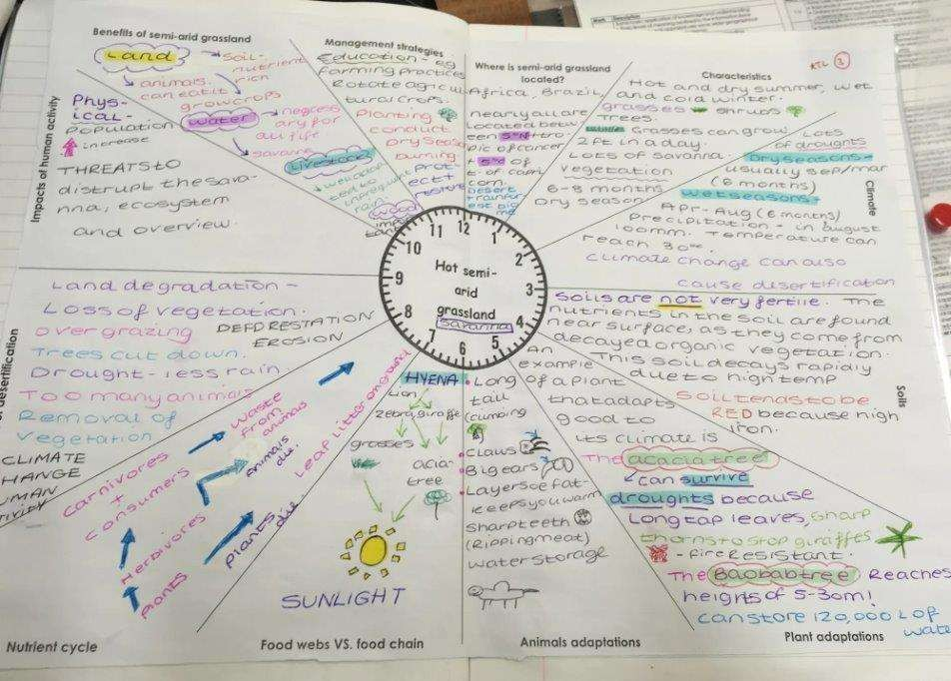

4. Mind Mapping
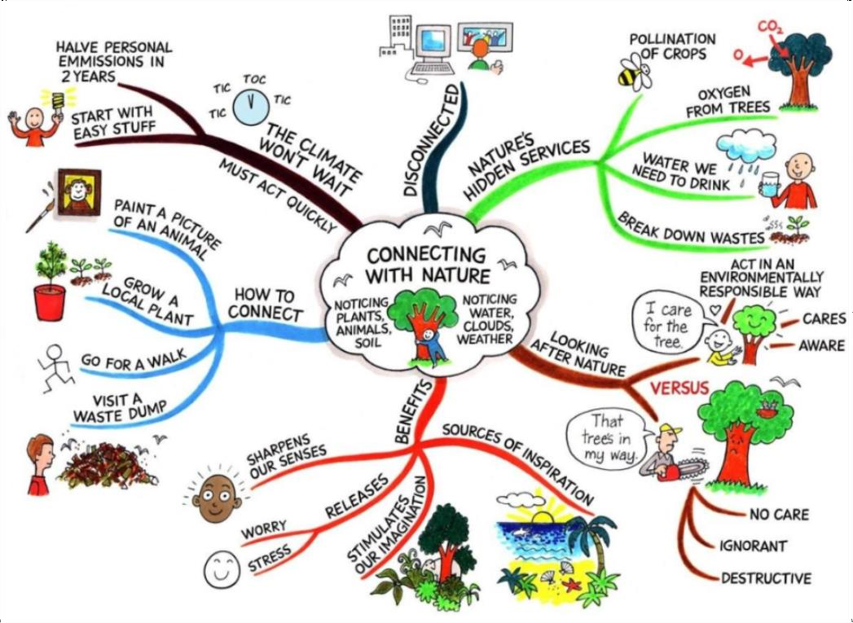

Instructions to create a mind map
- A mind map is a diagram that visually represents all of the information you need to learn
- Read all of the information you need to remember
- Start your mind map in the middle of the page adding a colourful image to the centre
- Start in the middle with the name of your topic. Add branches for each sub topic that you need to revise
- Build your network of information using colours and/or images
- The map that develop will be a vibrant and colourful network of knowledge that links the information
- When you have finished try turning each branch back into a sentence
- Sketch Noting

- Sketch noting provides a visual anchor which can spark your memory and link to remembered facts when notes are reviewed or when writing in an exam
- Our brains are wired to take in a scene and process it, which means we can look at a sketch-note page and process it faster than we can with line-by-line notes

How to sketch note

- Start with a main headline/title
- Add key facts in boxes, clouds or speech bubbles
- Use doodles and images to remind you of key facts
- There is no set layout, make it personal to you

